INTRODUCTION TO CYBERSECURITY

ROUTERS/MODEMS/SWITCHES
TASK1: Draw a simple network diagram showing how a router, modem, and switch connect together in a typical home setup. Label each device and explain the role of each in one line on your diagram.
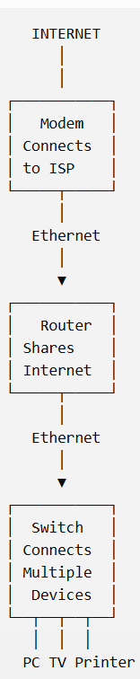
ROLE PF EACH DEVICES :
- Modem: Connects the home network to the Internet service provided by the ISP.
- Router: Connects different networks and shares the Internet with home devices.
- Switch: Connects multiple wired devices together in the same local network.
TASK2: Log in to your home WiFi router's admin panel (usually at 192.168.0.1 or 192.168.1.1) and find the section that shows connected devices. List the names or MAC addresses of at least 3 devices currently connected to your network.<br><br><em><strong>Hint:</strong> If you don't have access to a physical router, search online for a router admin demo page and use that for this task.</em>
- Connect your computer to your home Wi-Fi.
- Open a web browser.
- Enter the router's address in the address bar: 192.168.1.1 IF NOT WORK TRY THIS 192.168.0.1
- Enter your router's admin username and password.
- After logging in, find an option such as:
• Connected Devices
• Attached Devices
• Client List
• DHCP Clients
- Open that section.
- Note down at least 3 connected devices and their names or MAC addresses.
No. | Device Name | MAC Address
1 | My Laptop | 3C:52:82:AB:12:45
2 | My Smartphone | 8A:21:5C:44:67:90
3 | Smart TV | 70:4D:7B:23:91:56

TASK3: Create a table comparing routers, modems, and switches. Include at least 4 points for each: main function, where it is used (home/office), whether it assigns IP addresses, and if it supports WiFi.
Point | Router | Modem | Switch
Main Function | Connects networks and shares Internet | Connects home network to ISP | Connects multiple devices in a LAN
Used in | Home and office | Home and office | Home and mainly offices
Assigns IP Addresses | Yes, usually using DHCP | Usually no | No, normally
Wi-Fi Support | Many routers support Wi-Fi | Usually no, but some modem-router combos do | No
Connects Devices | Wired and wireless devices | Router/network to ISP | Multiple wired devices
Example | Wi-Fi router | Cable/DSL/Fiber modem | Ethernet switch

TASK4: Imagine you are setting up a small gaming café. Choose and specify which devices (router, modem, switch) you would need, how many of each, and briefly explain the reason for each choice.<br><br><em><strong>Hint:</strong> Consider the number of computers, internet connection, and need for wired vs wireless access.</em>
Example Setup
Suppose my gaming café has 10 gaming computers.
Device | Quantity | Reason
Modem/ONT | 1 | To connect the café to the ISP Internet connection
Router | 1 | To manage the network, provide Internet access and DHCP
24-Port Switch | 1 | To connect all 10 gaming PCs using Ethernet cables
Wi-Fi Access Point | 1 | To provide Wi-Fi for customers' phones
Ethernet Cables | 10+ | To connect the gaming PCs to the switch

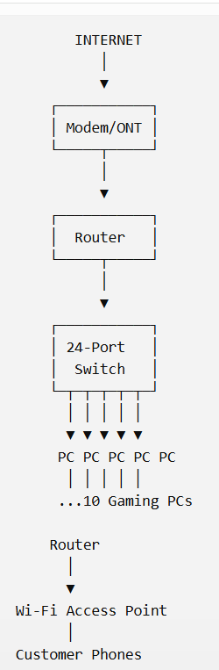
WHY I CHOOSE THESE :
- 1 Modem/ONT: Required to receive Internet service from the ISP.
- 1 Router: Manages the network and provides Internet access to all devices.
- 1 24-port switch: Provides enough Ethernet ports for 10 gaming PCs and allows future expansion.
- 1 Access Point: Provides Wi-Fi for customers' smartphones and other wireless devices.
- Ethernet cables: Wired connections are preferred for gaming because they generally provide stable and low-latency connectivity.

